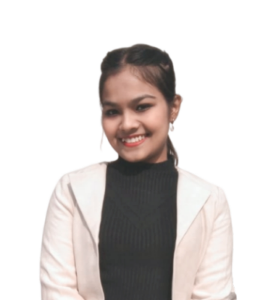

**PARAMPREET KAUR**

E-mail: parampreet2340@gmail.com

Phone: +91 7087920340

LinkedIn: [www.linkedin.com/in/parampreetkaur-7b8508264](http://www.linkedin.com/in/parampreetkaur-7b8508264)

Portfolio: https://parampreet12.github.io/portfolio/

Address: #340 Phase- 2, Mohali (Pb.)

**OBJECTIVE**

An enthusiastic and hardworking individual seeking employment. I am committed to utilizing my skills to further the mission of the company. I have a great passion for software development and analysis. My goal is to achieve a great position in an IT environment by doing satisfying and challenging work.

**TECHNICAL COMPETENCIES**

C++ | JAVA | WEB DEVELOPMENT | MySQL | ANDROID App. DEVELOPMENT | FULL STACK DEVELOPMENT

**INTERPERSONAL SKILLS**

Team Leadership **|** Management & Coordination **|** Decision Making

**INTERESTS & HOBBIES**

Dancing **|** Cooking **|** Listen Music

**LANGUAGES KNOWN**

English **|** Punjabi **|** Hindi

**STRENGTHS**

Honest **|** Punctual **|** Hard Working

**QUALIFICATION**

B.TECH in Computer Science Engineering | Rayat-Bahra University, V.P.O.Sauharn, Kharar, Punjab

*Session: 2021-2024 | Score: 7.15 CGPA*

Polytechnic Diploma in CSE |Chandigarh Polytechnic College

*Session: 2018-2021 | Percentage: 74%*

10th (CBSE) |Kendriya Vidyalaya, S.A.S Nagar, Mohali

*Session: 2016-2017 | Score: 5.8 CGPA*

**TRAINING & INTERNSHIP**

**Training | Internshala**

20th June 2020 to 15th August 2020

* Completed a 6-week online certified training on Web Development, the training consisted of HTML, CSS, BOOTSTRAP, SQL, and PHP modules.

**Internship | Solitaire Infosys Pvt. Ltd.**

11th July 2022 to 27th August 2022

* Completed a 6-Week Internship from Solitaire Infosys based on Android App Development.

**Training | In-House (in College)**

1st January 2023 to 30th January 2023

* Completed a 1-month certified training on JAVA and MySQL.

**Training | In-House (in College)**

10th July 2023 to 20th August 2023

* Completed a 6-week certified training on Full Stack Development, the training consisted of Front-End and Back-End.

**PROJECTS**

* **Grocery Store (2020)**

**Role:** worked on the performance and designing of the of the overall site

**Goal:** A website was created with an idea to make local shop holders sell their grocery items online at less price than the online market.

* **CaRental (2021)**

**Role:** worked as a web designer and database designer, and developed the admin part of the website

**Goal:** A website which makes car renting easy now consumer can rent a car and drive by their own.